**Delete Duplicate Records**

# Scenario 1: Data duplicated based on SOME of the columns.

# Write a query to Delete duplicate data from Cars table.

# Duplicate record is identified based on the model and brand name.

**select * from ex_cars order by model, brand;**

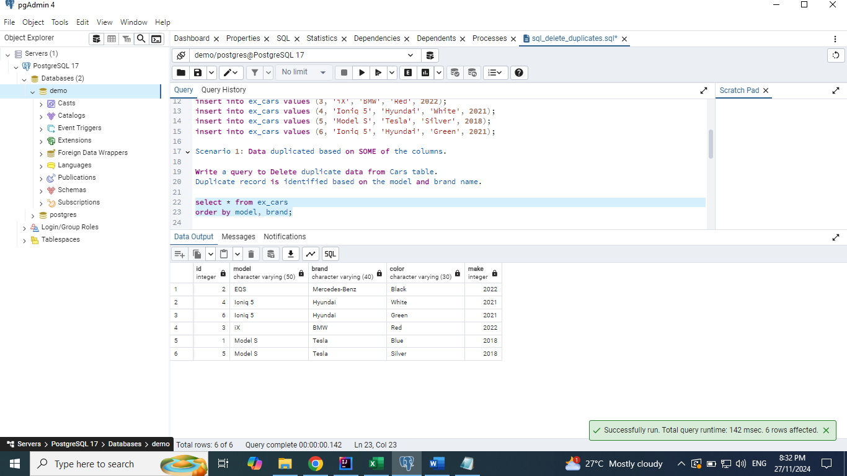

## Solution 1: Delete using Unique Identifier

**select model, brand, count(*)**

**from ex_cars**

**group by model, brand**

**having count(*) > 1;**

**select model, brand, max(id)**

**from ex_cars**

**group by model, brand**

**having count(*) > 1;**

**delete from ex_cars**

**where id in**

**(select max(id)**

**from ex_cars**

**group by model, brand**

**having count(*) > 1);**

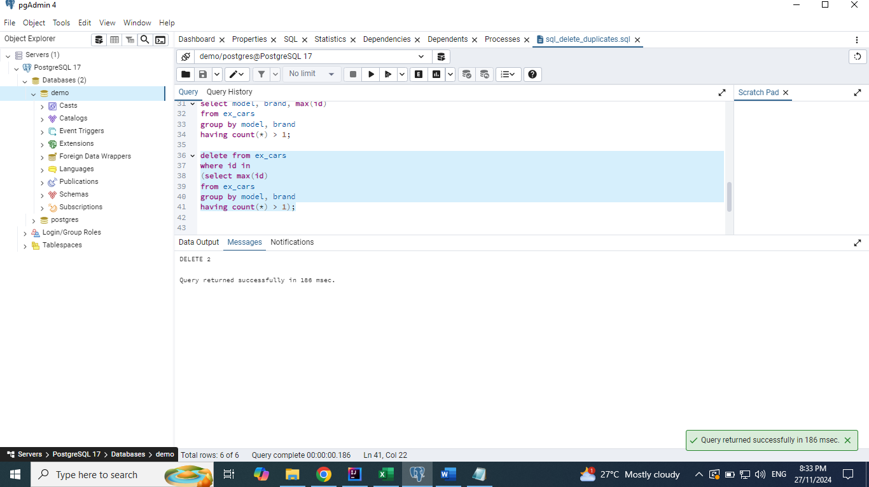

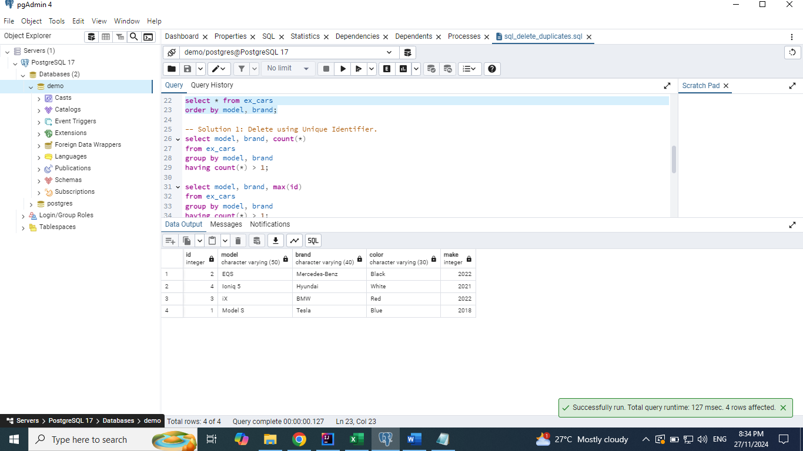

## Solution 2: Using Self join

**select \***

**from ex_cars c1**

**join ex_cars c2**

**on c1.model = c2.model and c1.brand = c2.brand**

**where c1.id < c2.id;**

**select c2.\***

**from ex_cars c1**

**join ex_cars c2**

**on c1.model = c2.model and c1.brand = c2.brand**

**where c1.id < c2.id;**

**delete from ex_cars**

**where id in**

**(select c2.id**

**from ex_cars c1**

**join ex_cars c2**

**on c1.model = c2.model and c1.brand = c2.brand**

**where c1.id < c2.id);**

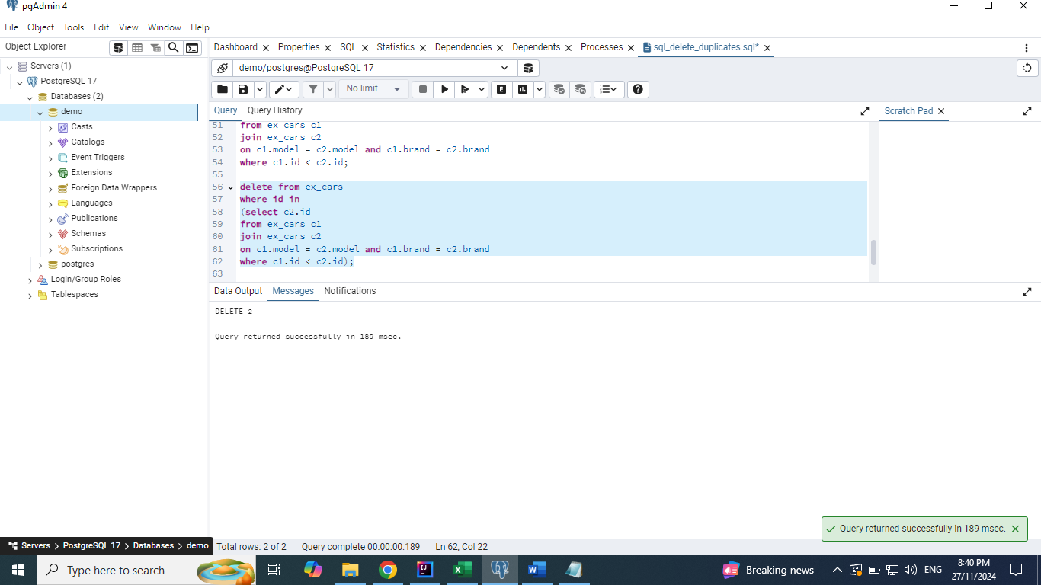

## Solution 3: Using Window function

**select *,**

**row_number() over(partition by model, brand) as rn**

**from ex_cars;**

**select id**

**from**

**(select *,**

**row_number() over(partition by model, brand) as rn**

**from ex_cars ) x**

**where x.rn > 1;**

**delete from ex_cars**

**where id in**

**(select id**

**from**

**(select *,**

**row_number() over(partition by model, brand) as rn**

**from ex_cars ) x**

**where x.rn > 1);**

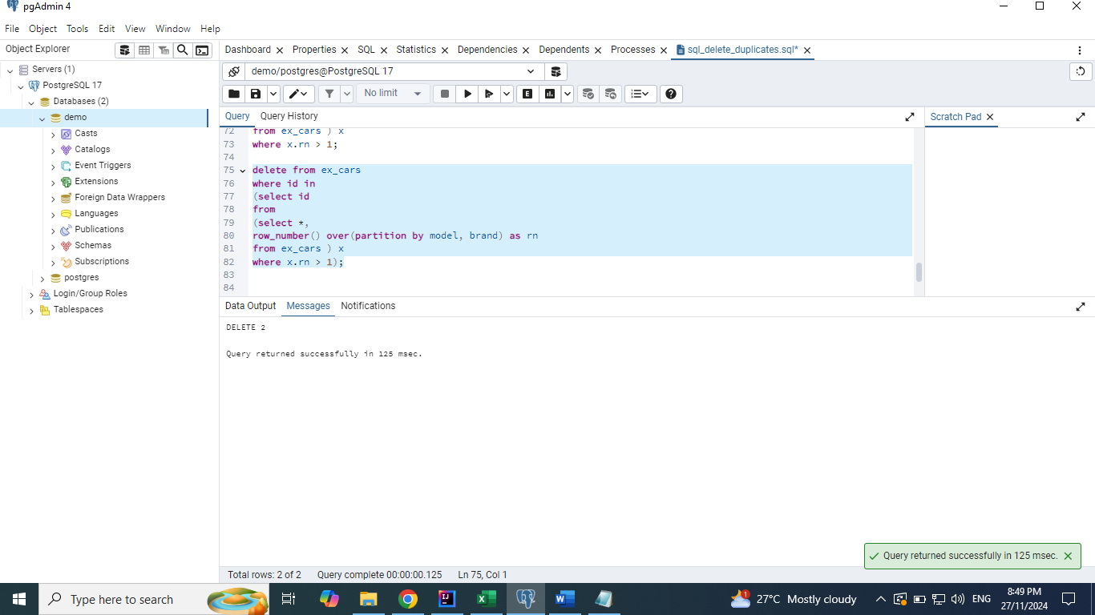

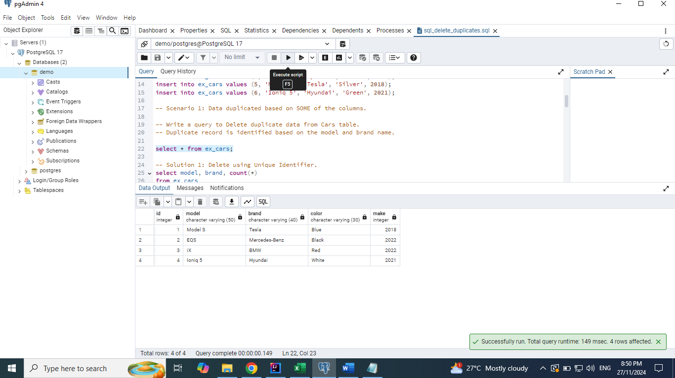

## Solution 4: Using Min function. This deletes even multiple duplicate records

**select min(id)**

**from ex_cars**

**group by model, brand;**

**delete from ex_cars**

**where id not in**

**(select min(id)**

**from ex_cars**

**group by model, brand);**

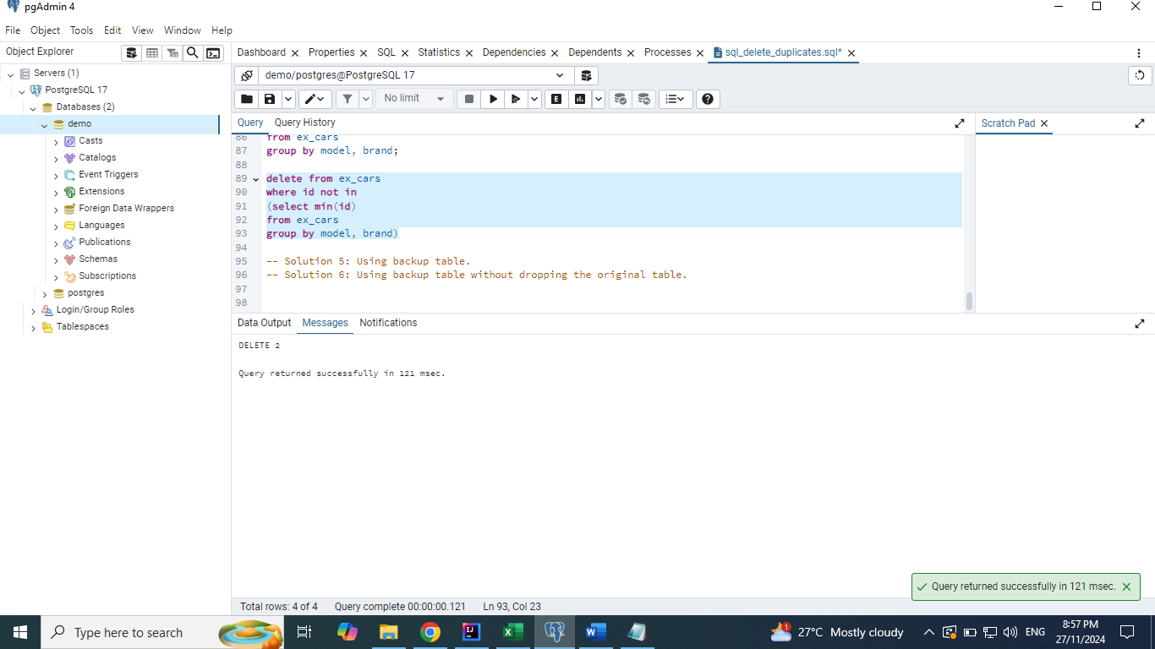

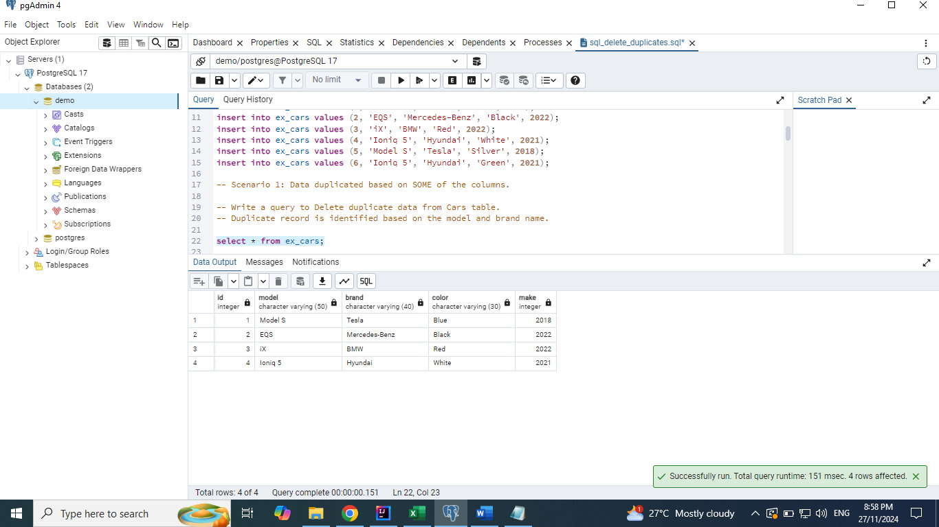

## Solution 5: Using backup table.

**The below statement creates the backup table as per the ex_cars table without the data.**

**select * from ex_cars_bkp;**

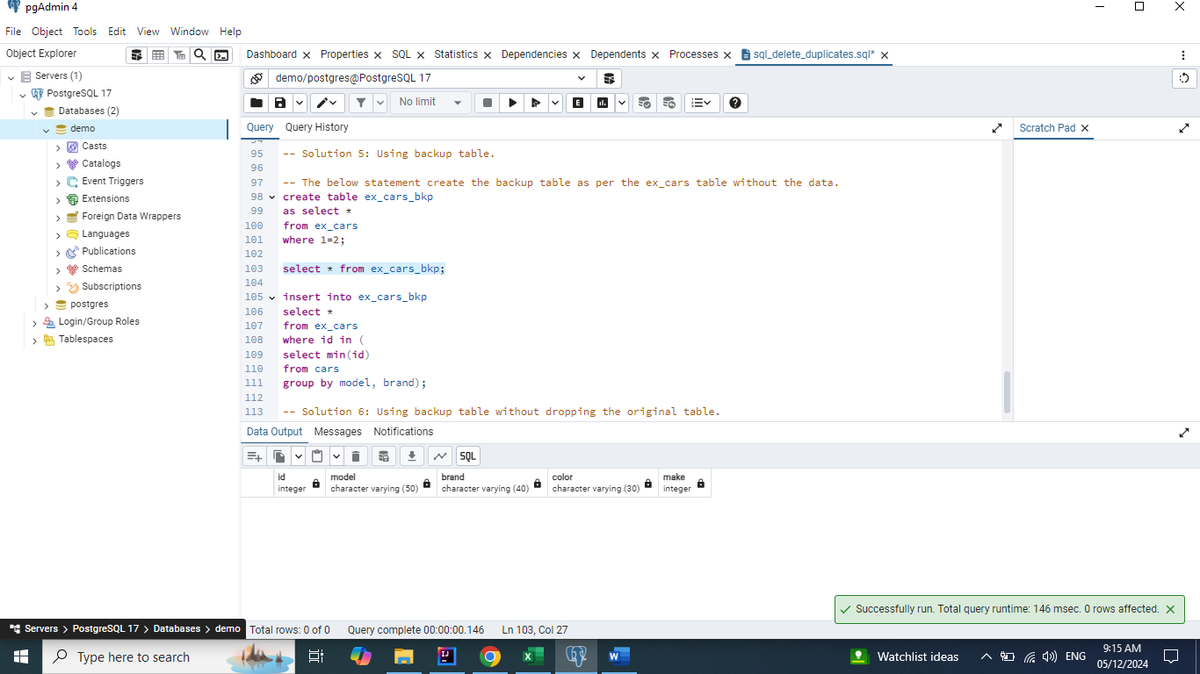

**insert into ex_cars_bkp**

**select \***

**from ex_cars**

**where id in (**

**select min(id)**

**from ex_cars**

**group by model, brand);**

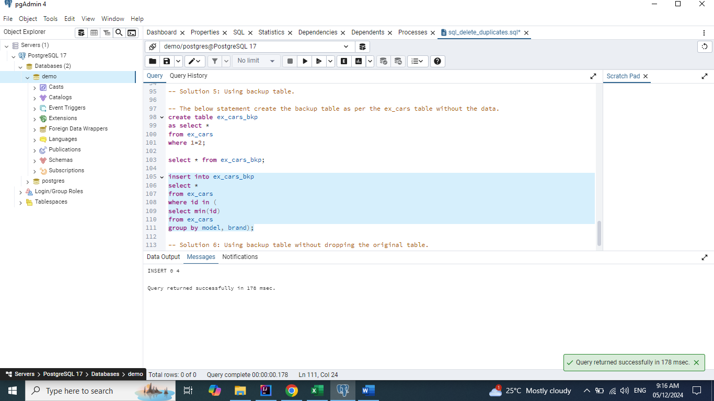

**select * from ex_cars_bkp;**

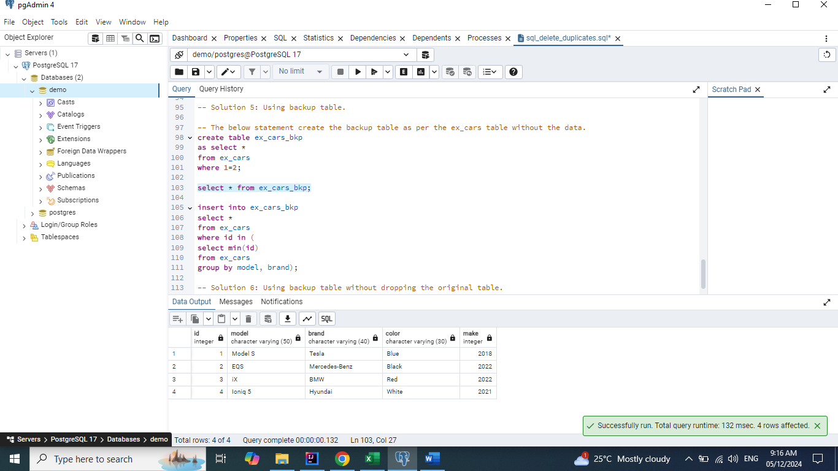

**drop table ex_cars;**

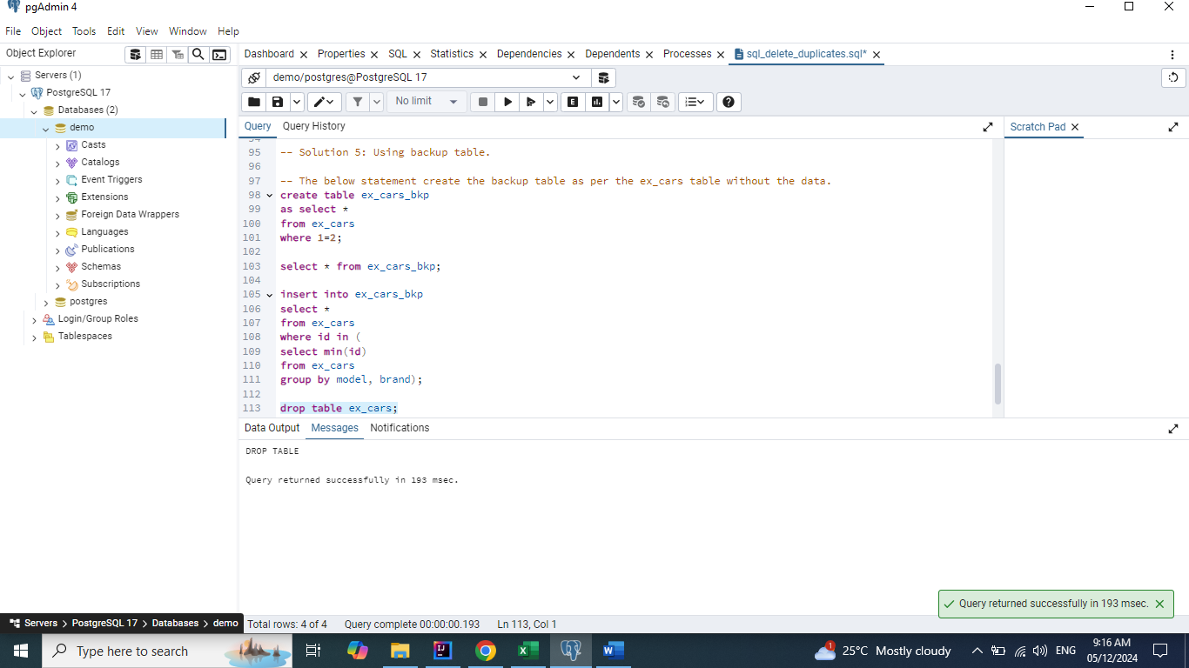

**alter table ex_cars_bkp rename to ex_cars;**

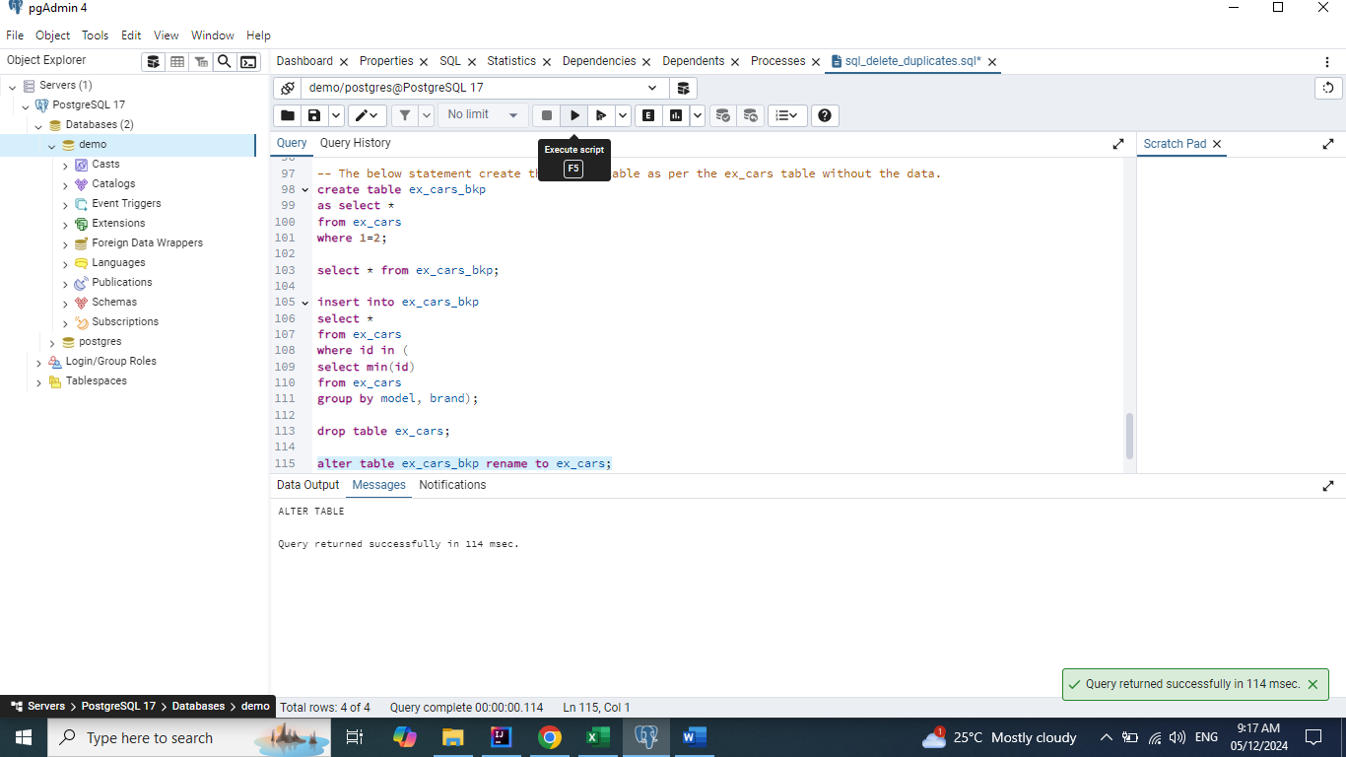

**select * from ex_cars;**

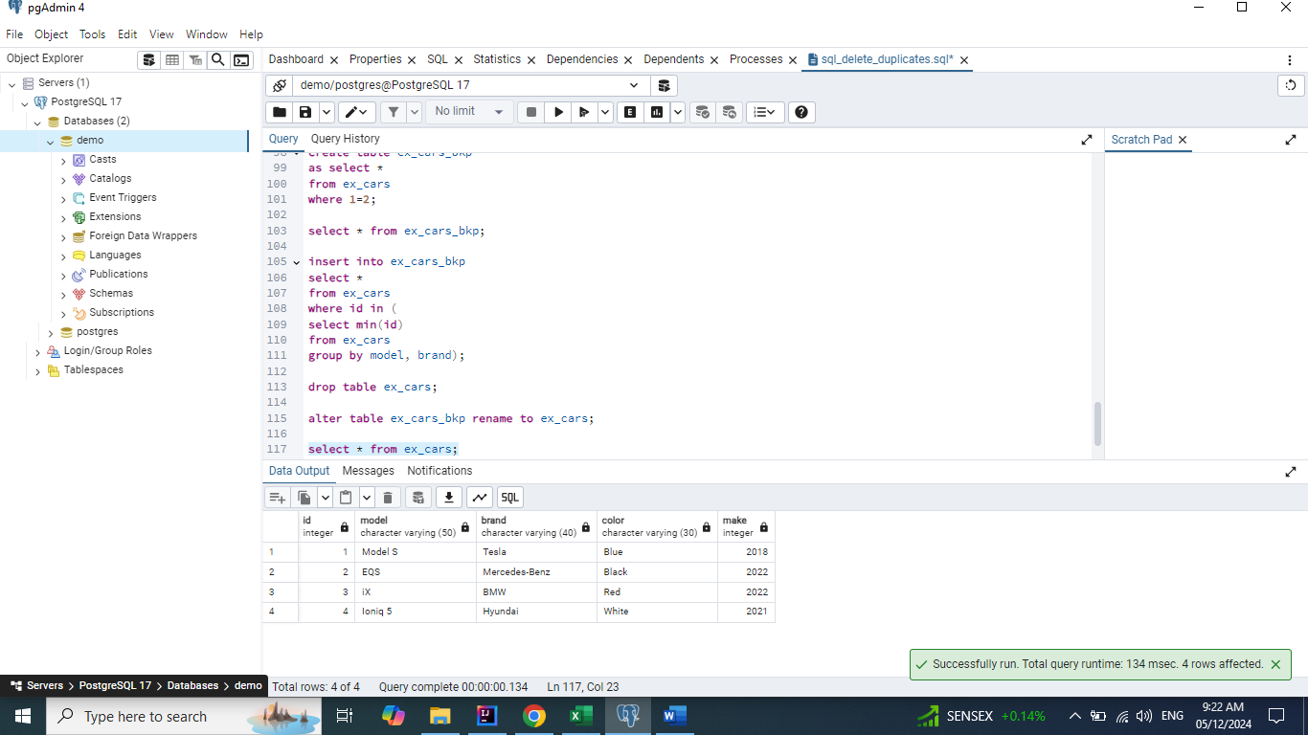

## Solution 6: Using backup table without dropping the original table.

**create table ex_cars_bkp**

**as select \***

**from ex_cars**

**where 1=2;**

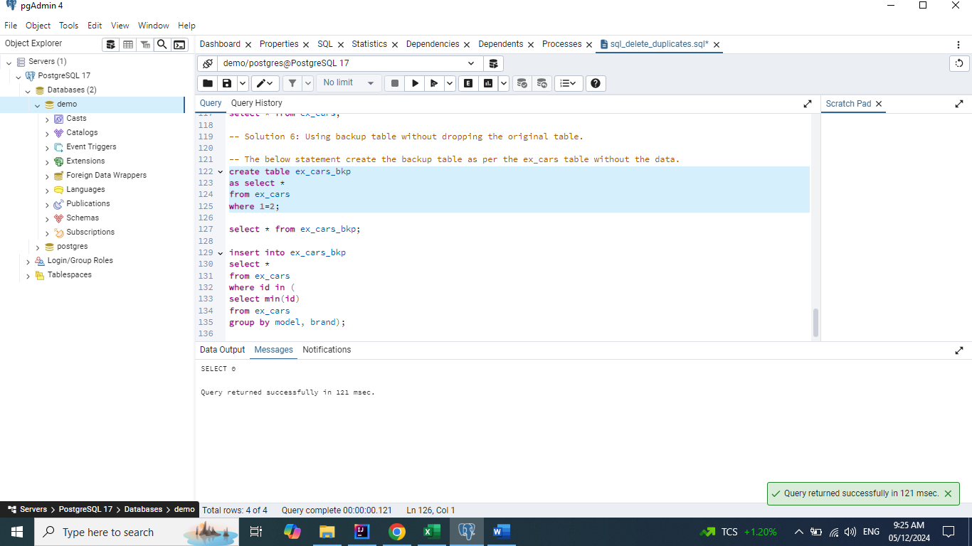

**select * from ex_cars_bkp;**

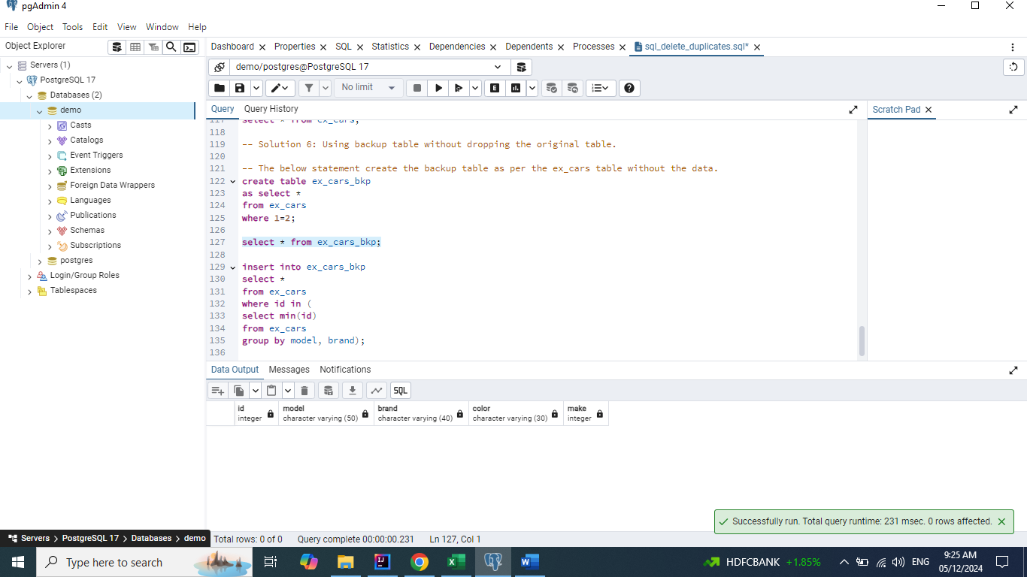

**insert into ex_cars_bkp**

**select \***

**from ex_cars**

**where id in (**

**select min(id)**

**from ex_cars**

**group by model, brand);**

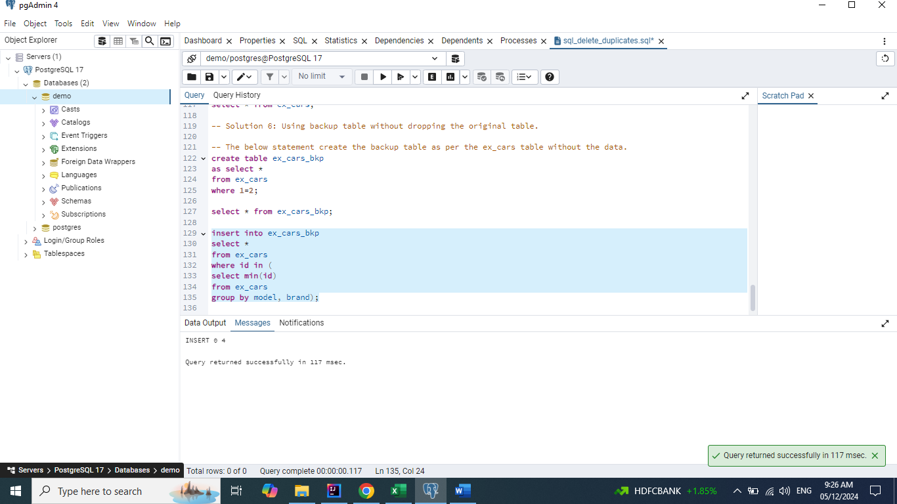

**truncate table ex_cars;**

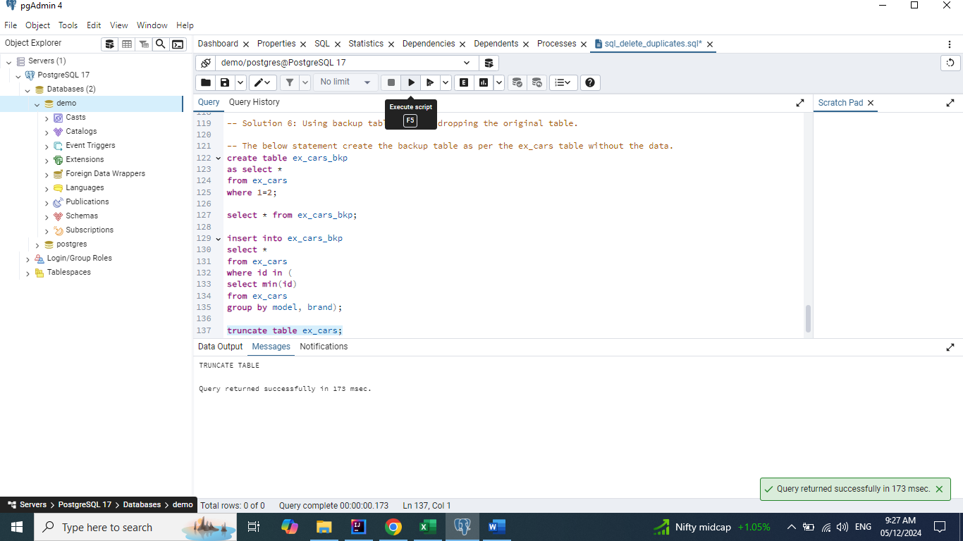

**insert into ex_cars**

**select * from ex_cars_bkp;**

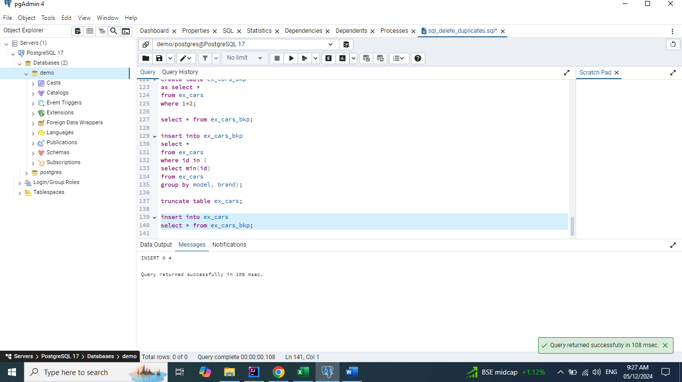

**drop table ex_cars_bkp;**

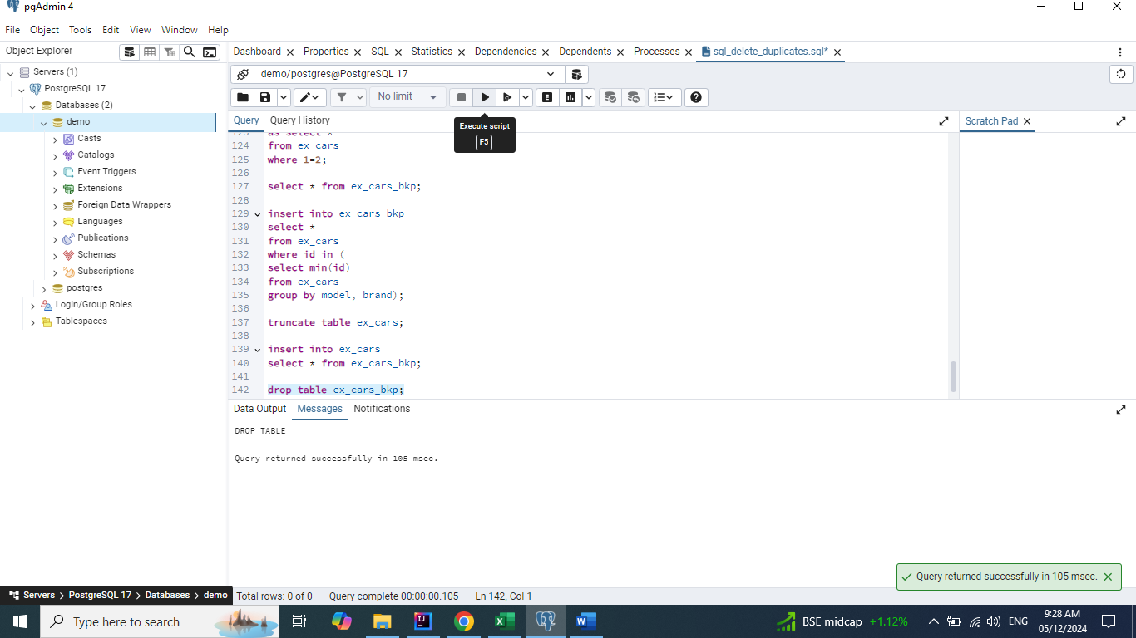

**select * from ex_cars;**

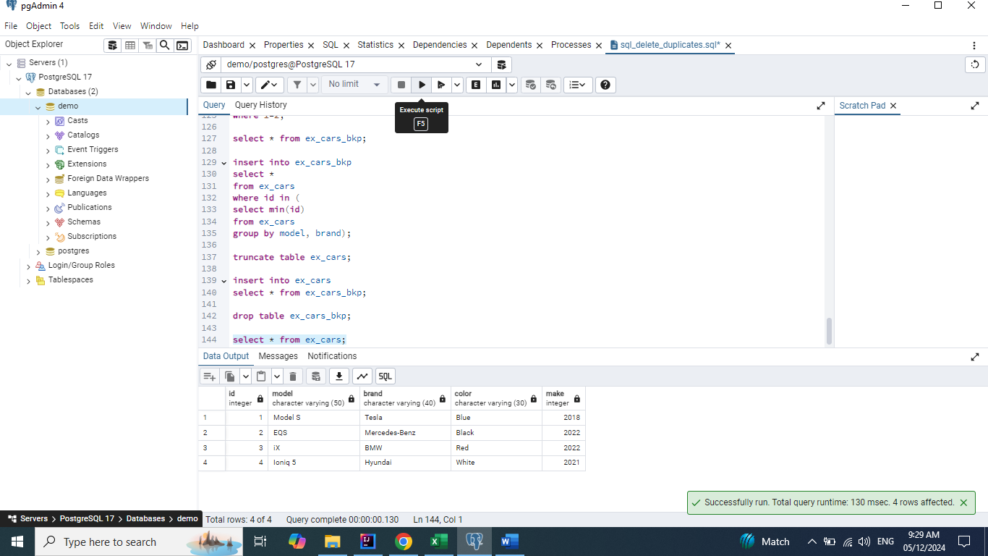

# Delete the records even if the Id is duplicate.

## Solution 1: Delete using CTID [CTID available in Postgres SQL / ROWID available in Oracle]

**The above solution will not work in MySQL and Microsoft SQL Server.**

**select * from ex_cars;**

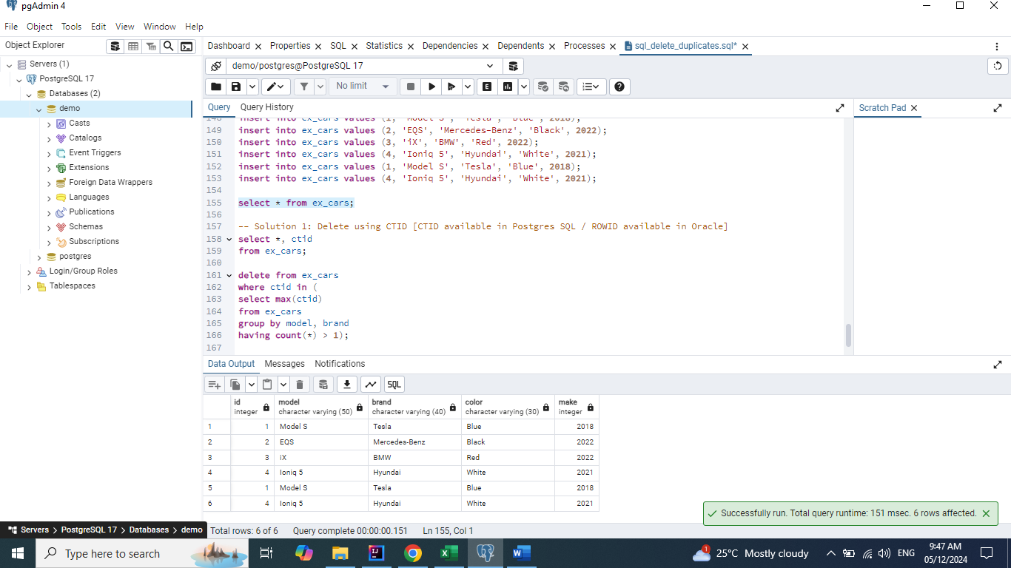

**select *, ctid**

**from ex_cars;**

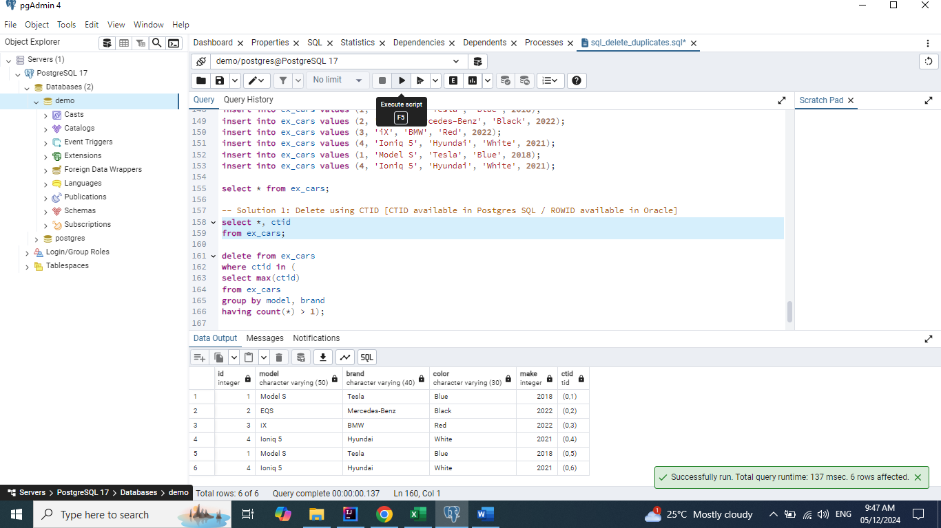

**delete from ex_cars**

**where ctid in (**

**select max(ctid)**

**from ex_cars**

**group by model, brand**

**having count(*) > 1);**

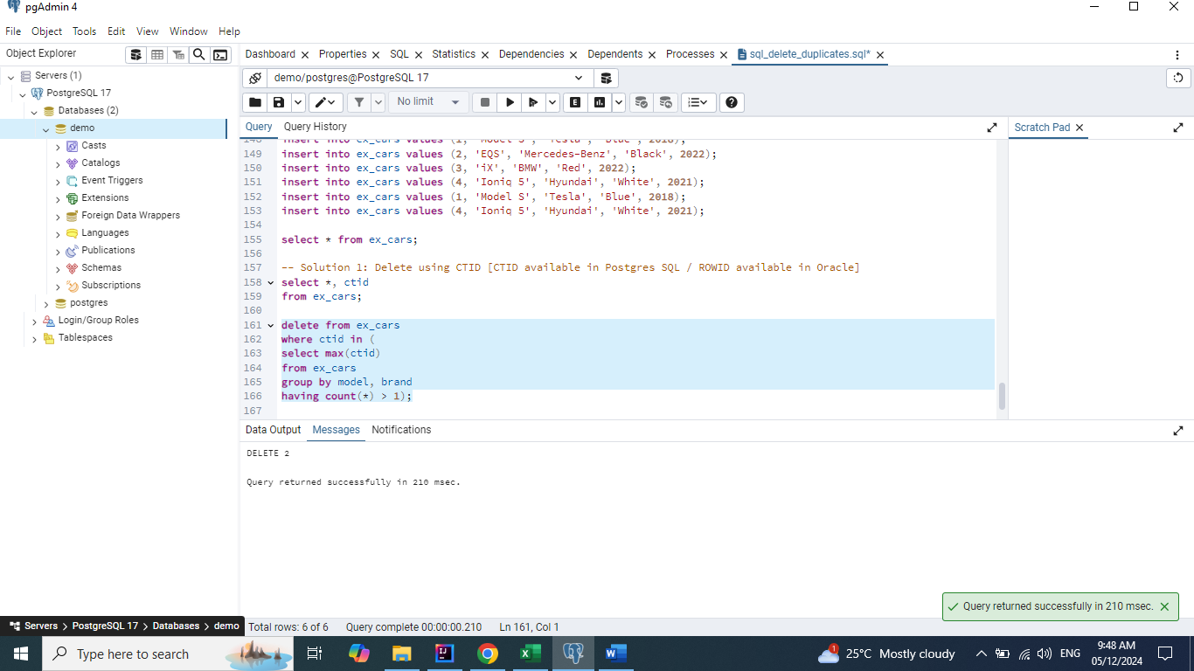

**select * from ex_cars order by model, brand;**

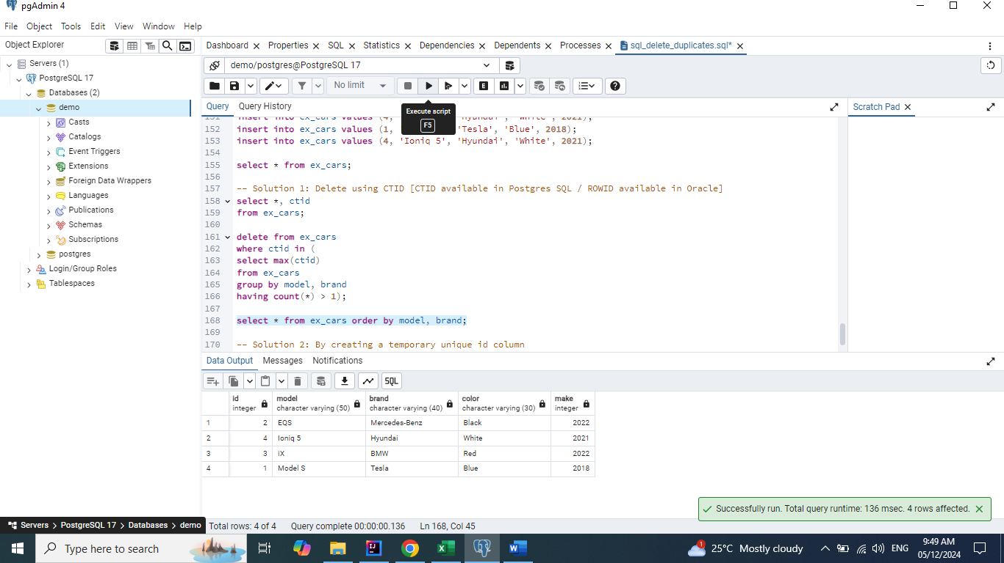

## Solution 2: By creating a temporary unique id column

**alter table ex_cars add column row_num int generated always as identity;**

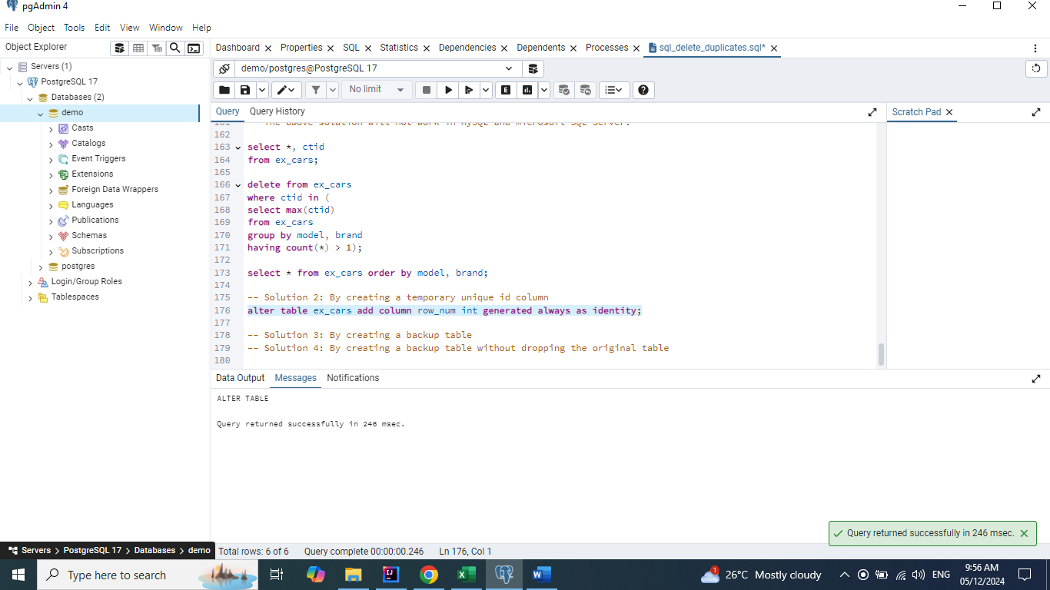

**select * from ex_cars order by model, brand;**

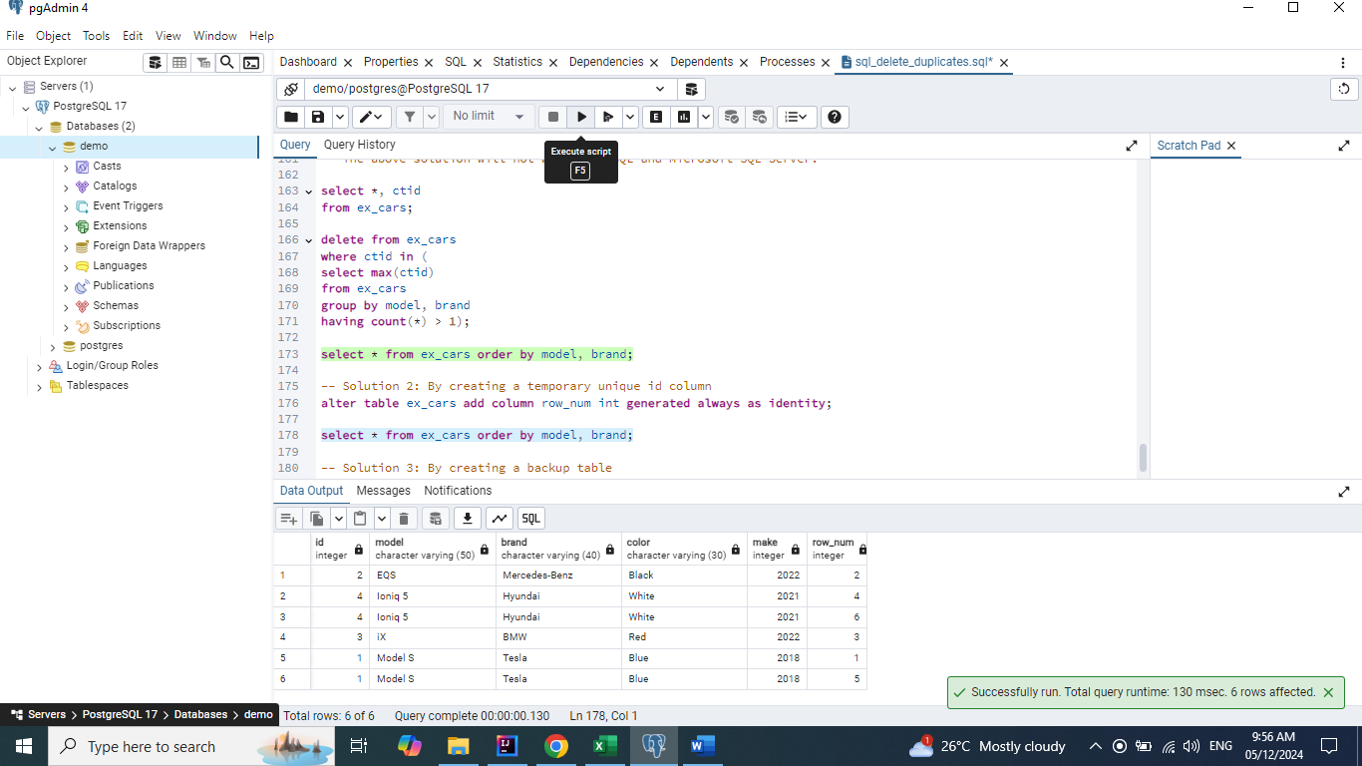

**select max (row_num)**

**from ex_cars**

**group by model, brand**

**having count(*) > 1;**

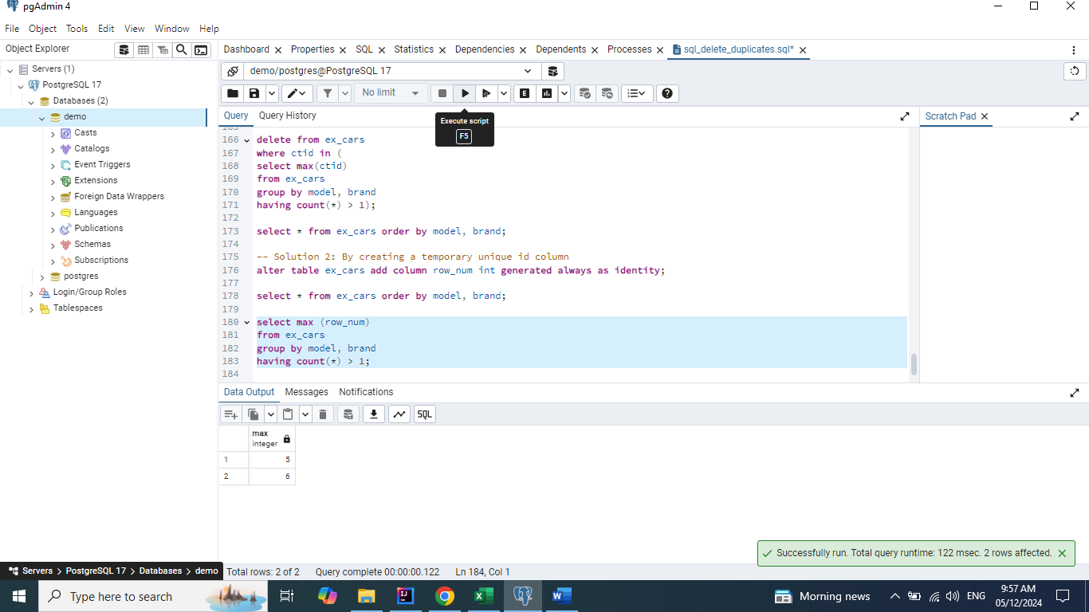

**delete from ex_cars**

**where row_num in**

**(select max (row_num)**

**from ex_cars**

**group by model, brand**

**having count(*) > 1);**

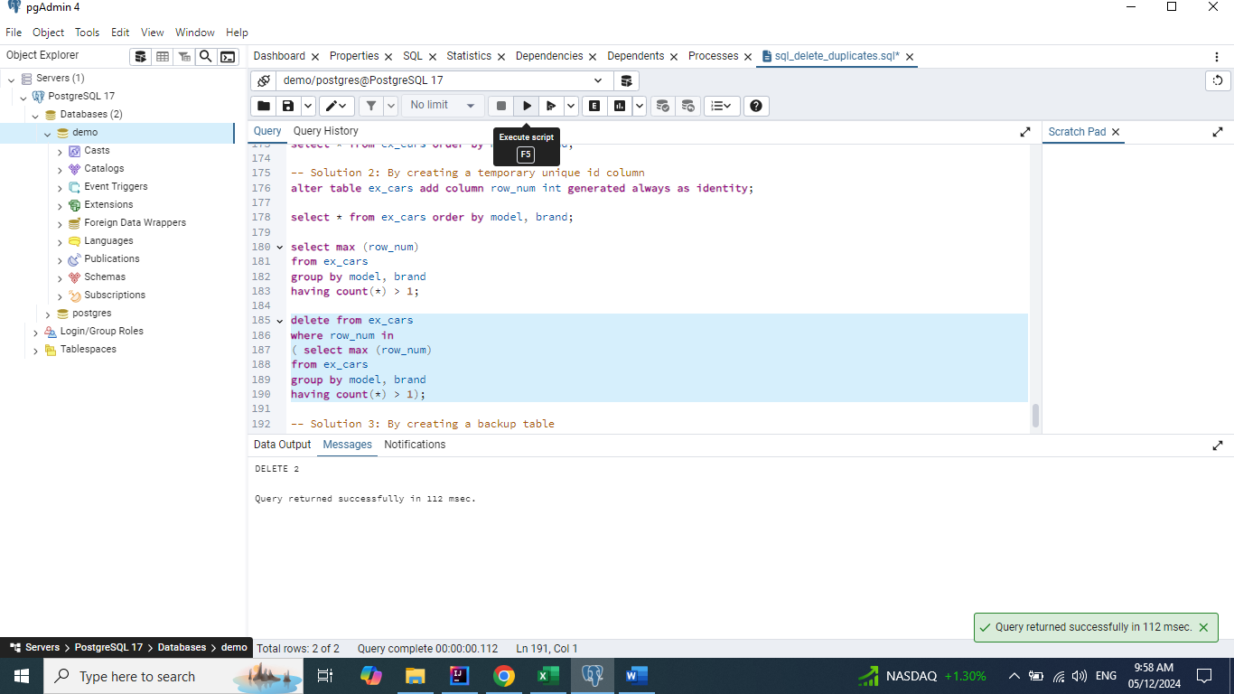

**select * from ex_cars order by model, brand;**

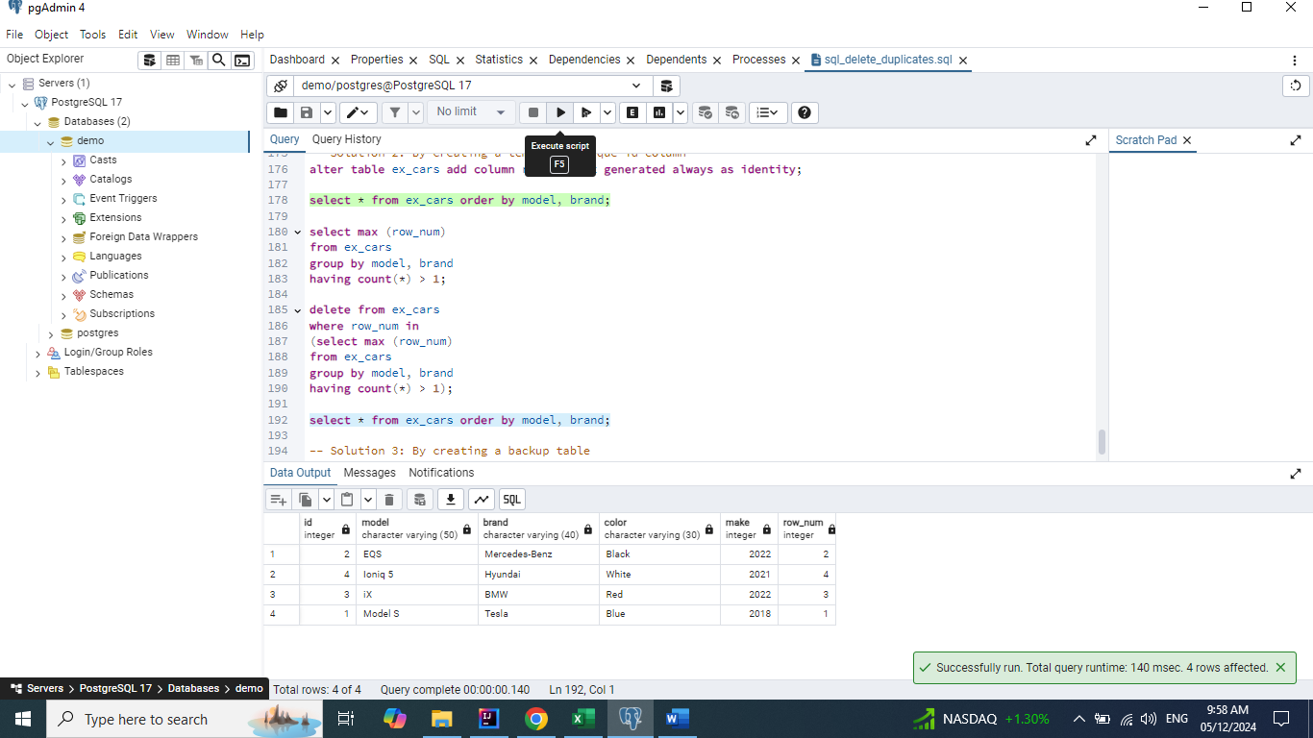

**alter table ex_cars drop column row_num;**

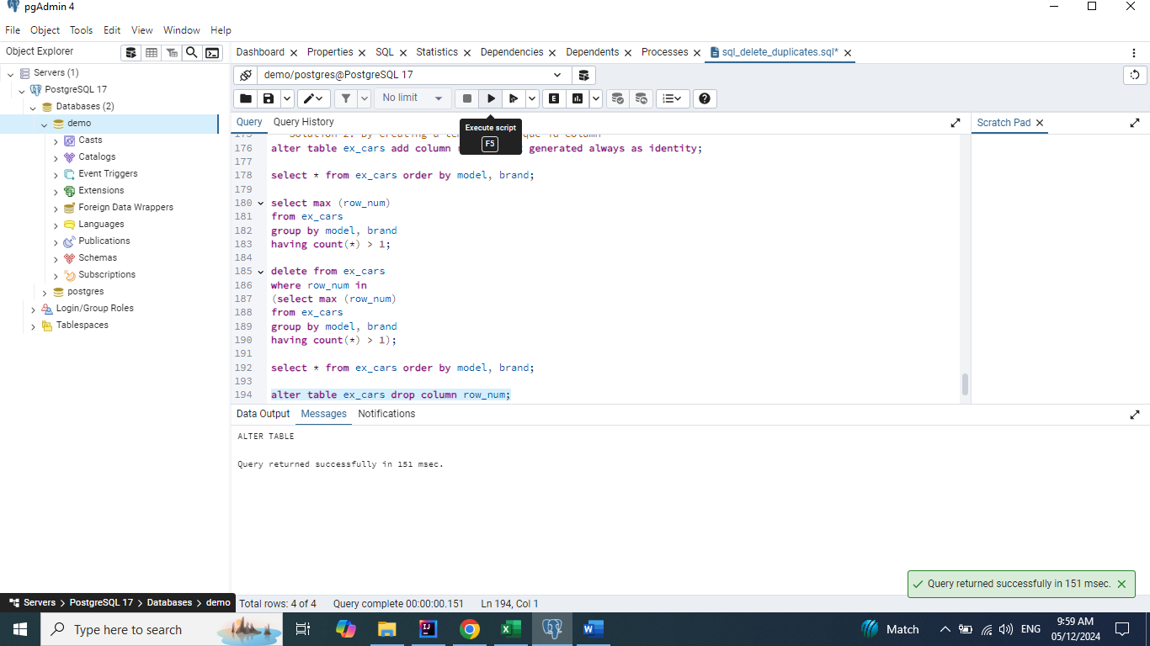

**select * from ex_cars order by model, brand;**

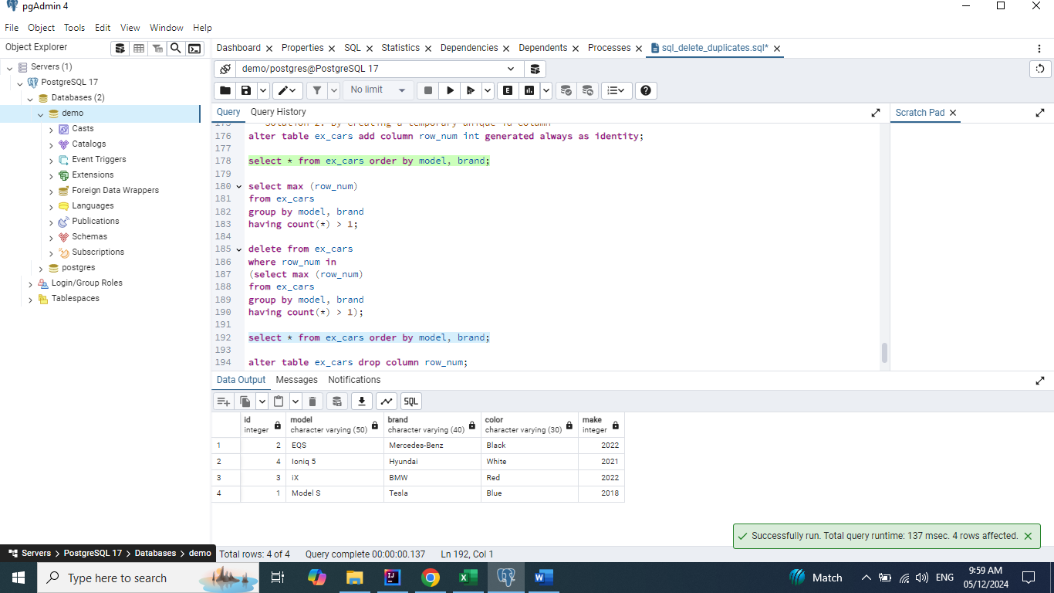

## Solution 3: By creating a backup table

## Solution 4: By creating a backup table without dropping the original table